# CS 255 System Design Document Template

## UML Diagrams

### UML Use Case Diagram

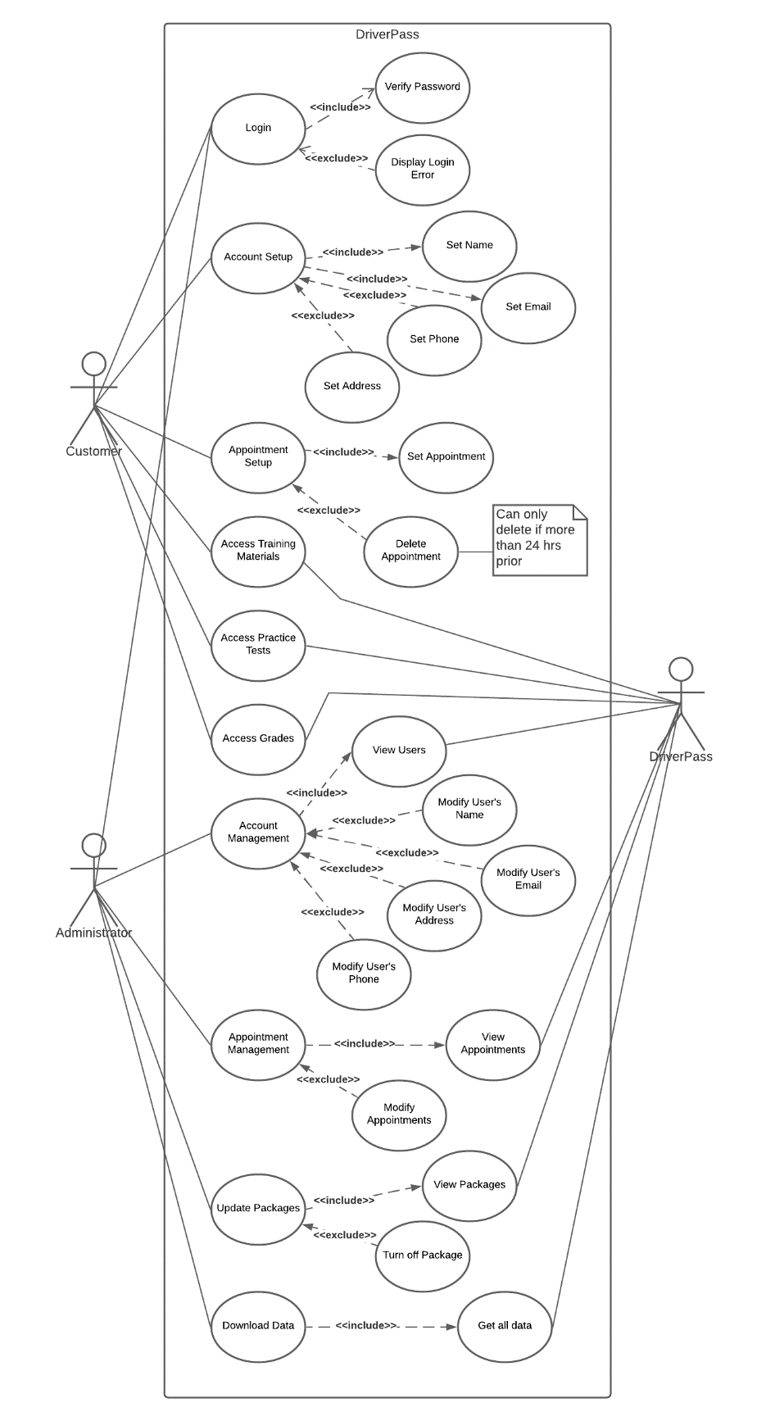

### UML Activity Diagrams

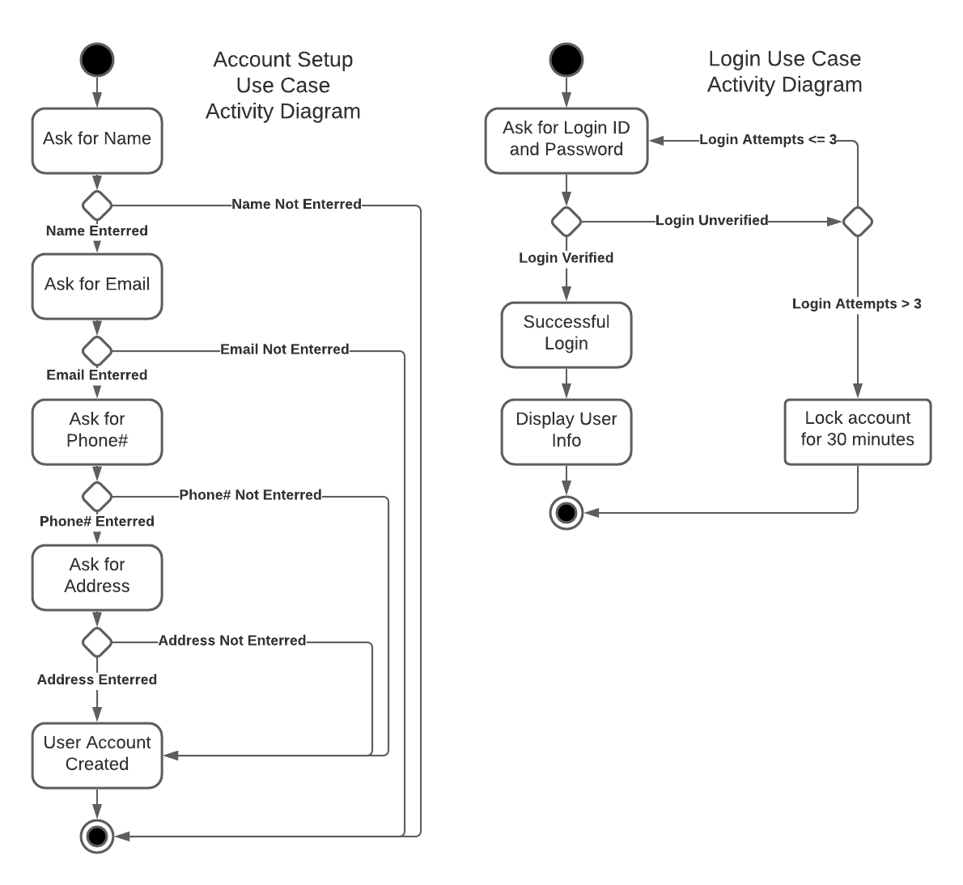

### UML Sequence Diagram

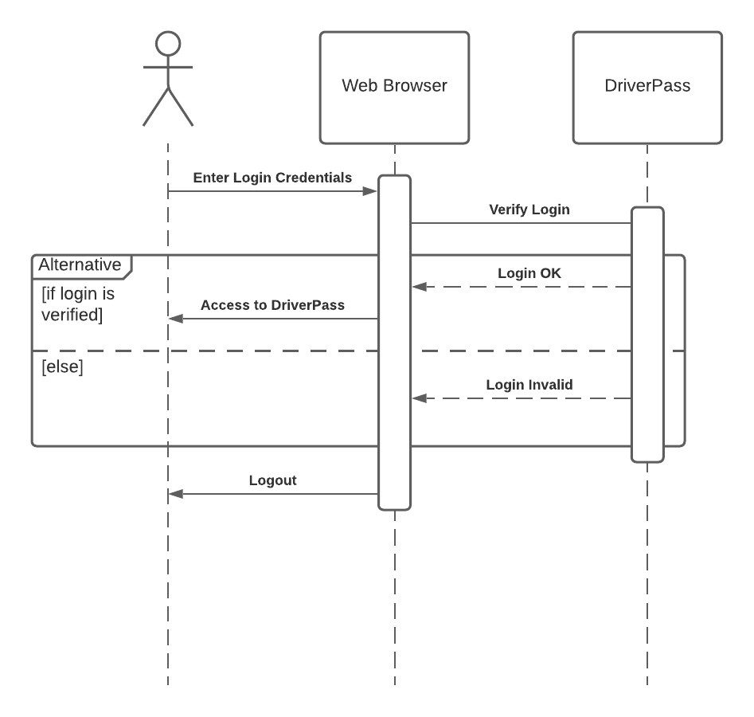

### UML Class Diagram

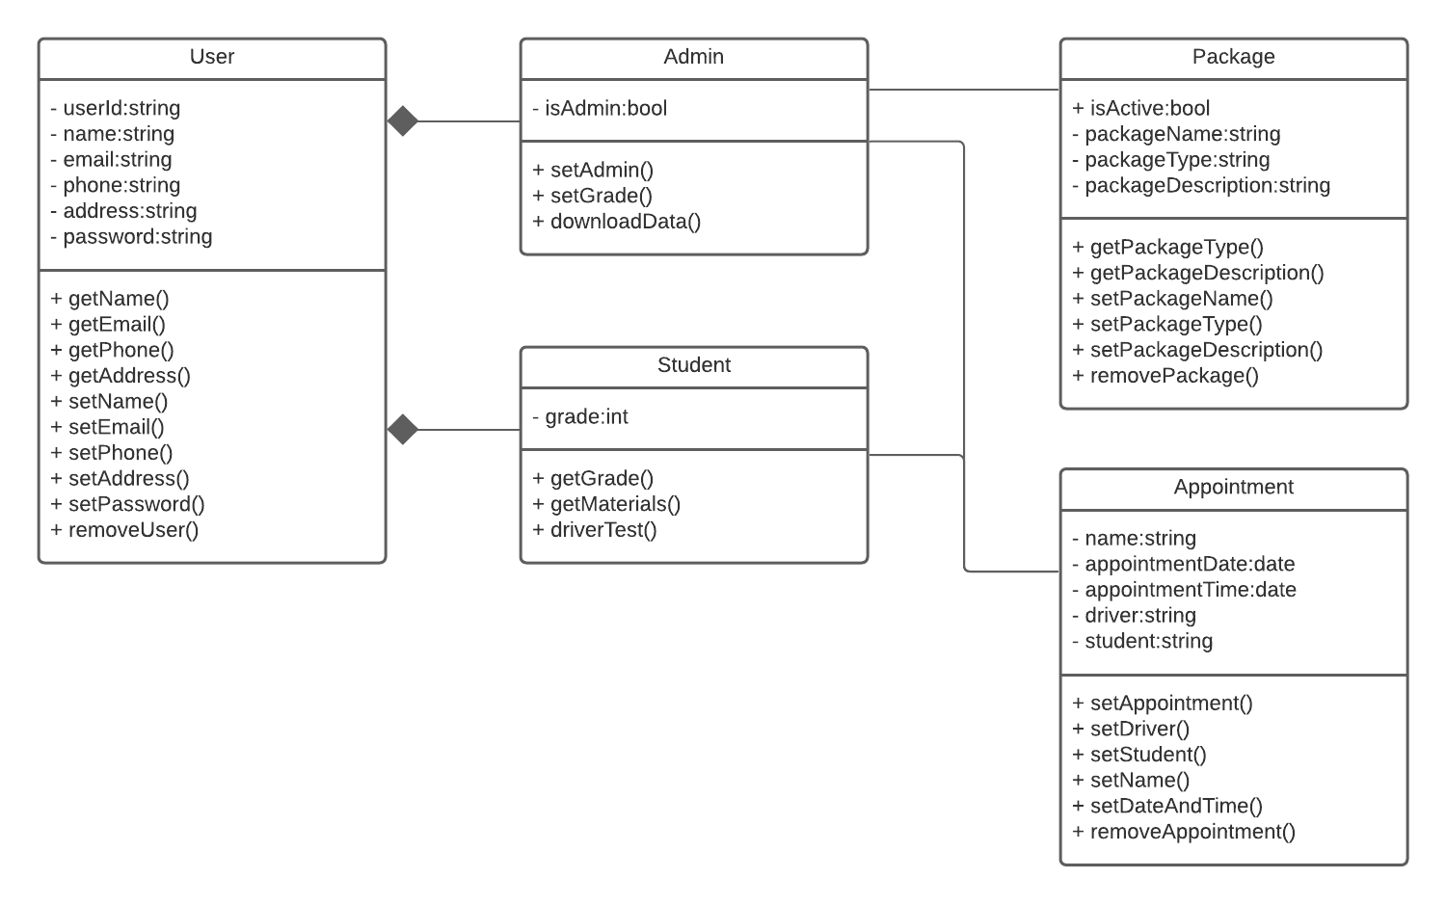

## Technical Requirements

*Website:*

* *Any modern supported browser*
* *Access to the internet*

*Mobile:*

* *Smartphone*
* *Apple or Android operating system*
* *3G & 4G Data Network*